Full year 2019
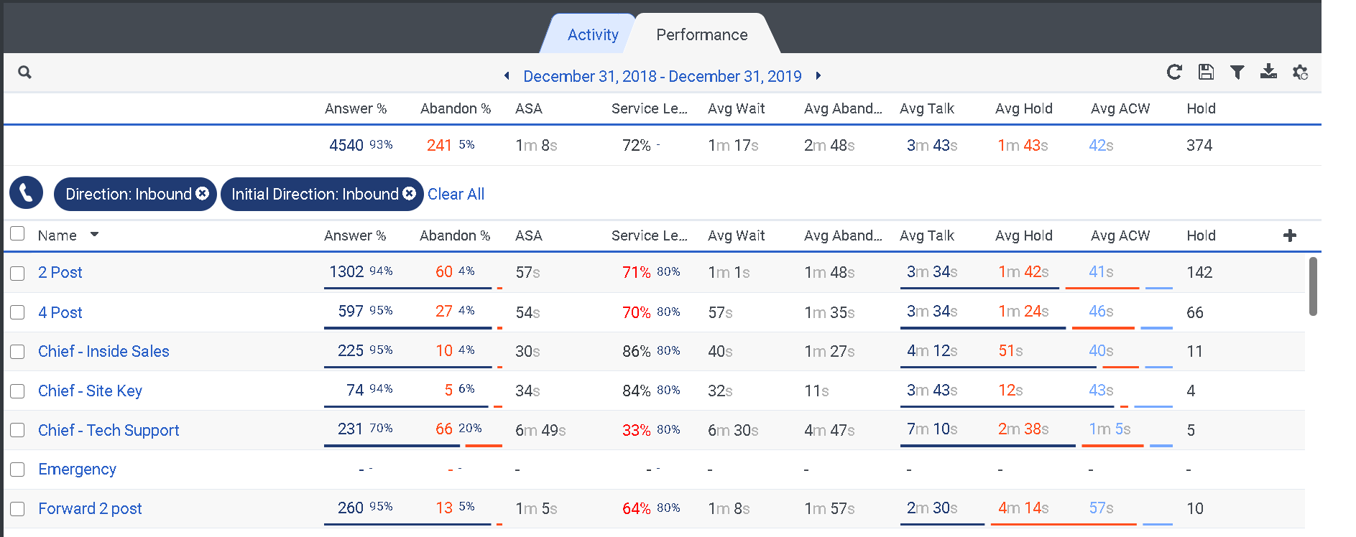
Full year 2020
Note it has the same numbers as the full year 2019
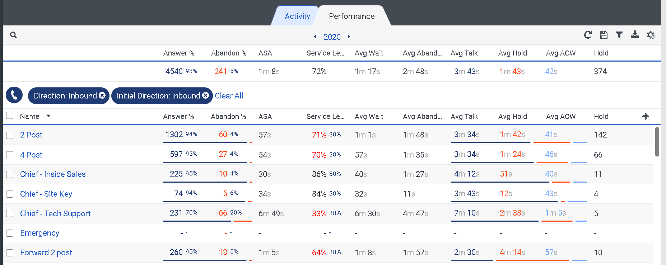
Failed Export ID’s
44b93cc8-41bc-4f3f-9b29-0417a92278f2
16a1f8aa-e5f6-4cd5-829c-f554a5540f51
06288bee-12f1-4d53-b391-4e8e34d99fb6
b0bcbbb1-da7c-4aff-97b4-6da8bd8df71b
781b8df0-c4c2-43b2-a06c-9ae2f7c3e7e0

