Instead of adjusting the setting on all the phones of the remote users. Create a line group just for remote users. See the instructions below.

Any questions, comments, or concerns, please reach out. Think of this as a working document.

1. Create a SIP line or lines to match your PSTN circuits. Make sure they have remote users in the name.

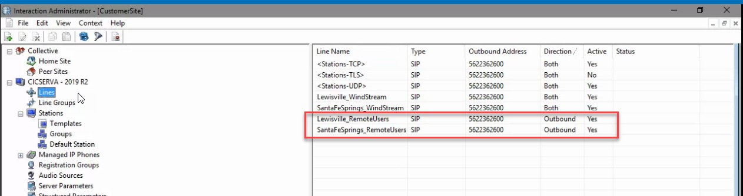

1. Make the line outbound only

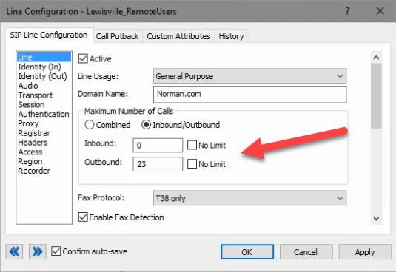

1. For the outbound identity, use the companies preferred number

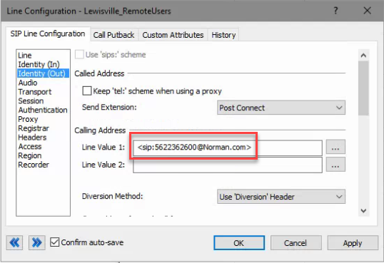

1. Change the following values to “Use line value 1”

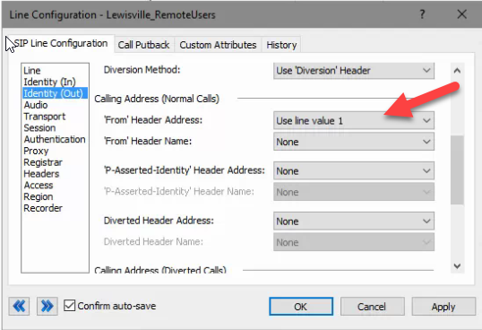

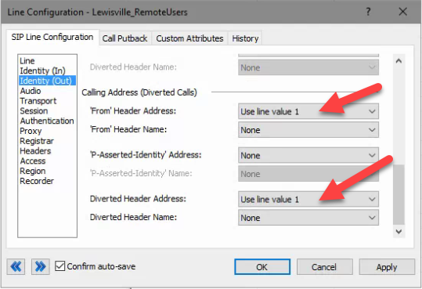

1. Assign the outbound proxy IP. This can be an SBC or gateway.

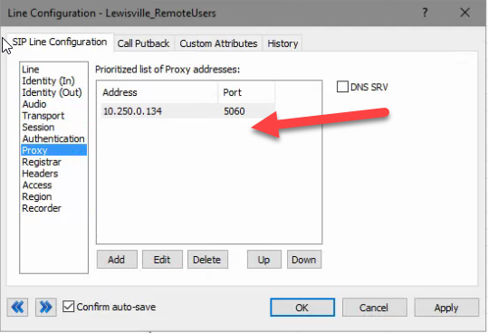

1. For access deny all inbound traffic

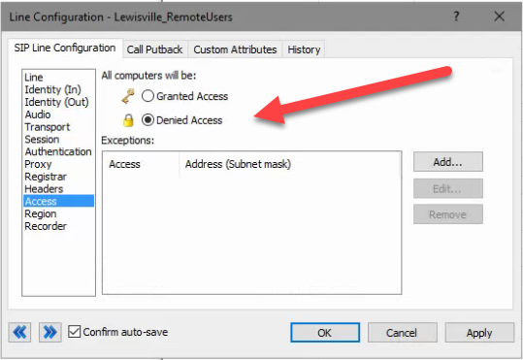

1. If the customer is using location assign location.

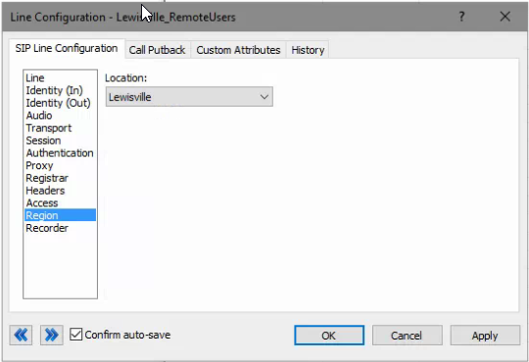

1. Create a line group for the remote users.

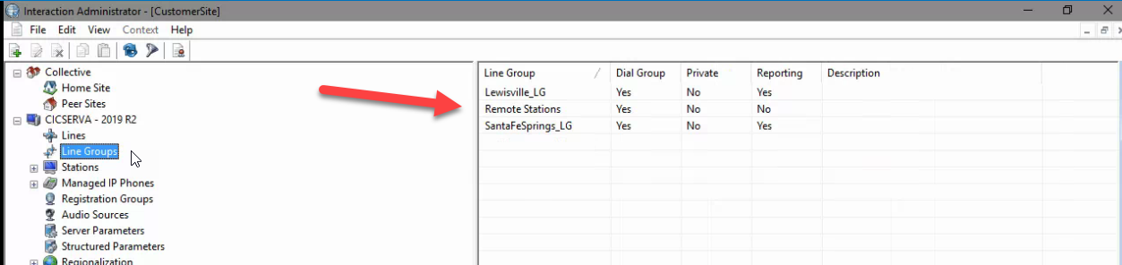

1. Use as a dial group only

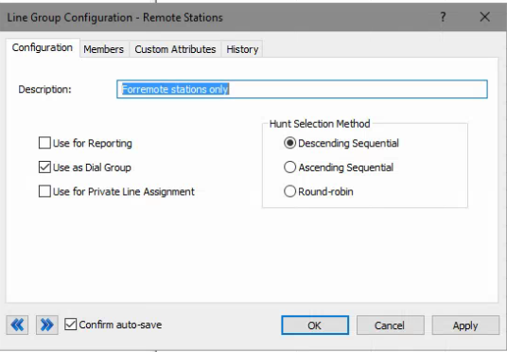

1. Add the SIP line you want to use for remote users.

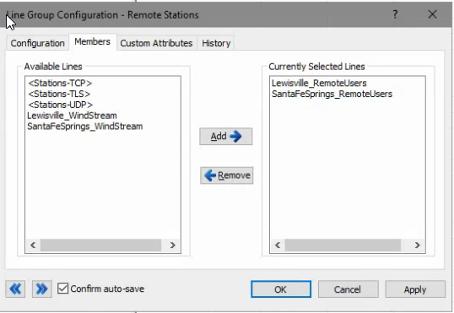

1. Assign the line group to be used by remote users.

