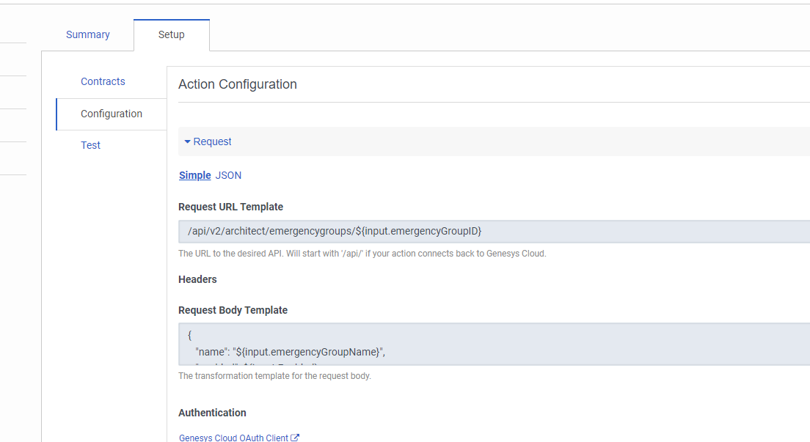
{
"name": "${input.emergencyGroupName}",
"enabled": ${input.Enabled},
"emergencyCallFlows": [
{
"emergencyFlow": {
"id": "${input.emergencyFlow}",
"selfUri": "/api/v2/flows/${input.emergencyFlow}"
},
"ivrs": [
{
"id": "${input.ivrs}",
"selfUri": "/api/v2/architect/ivrs/${input.ivrs}"
}
]
}
]
}

