Creating a group that dynamically updates based on rules
Genesys Cloud Admin
Directory
Groups
Add Group
- Make sure type = official
- Visibility = Owners only (which actually means Owners AND Members)
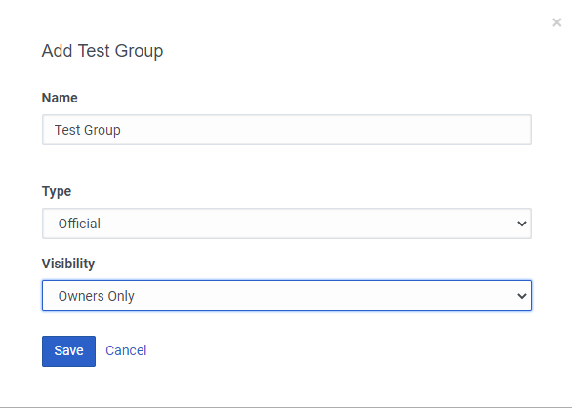
Click on the newly created group
Click on Edit to right of All Members
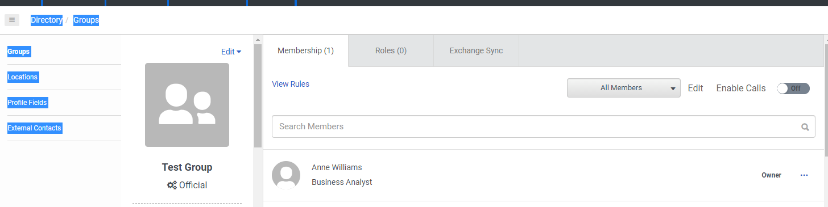
Click on Inclusions tab
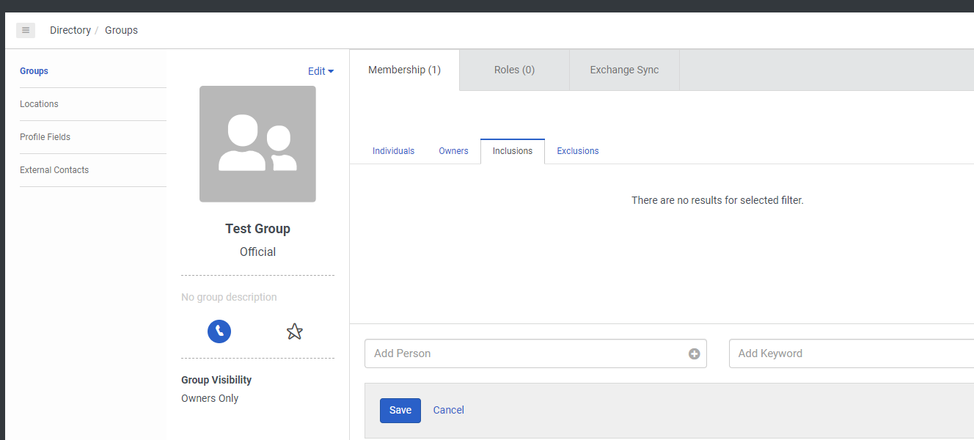
In the <Add Keyword> field, start typing in the Job Title (or Department, or Division, or whatever else you want to use from the People record).e.g. I start typing in “bus” and a window pops up with Business Analyst on…
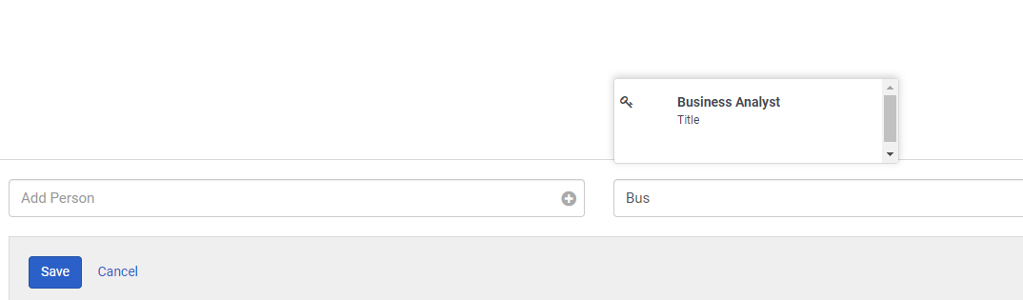
Select the correct key word when offered and it will be returned as a rule. You can go on to add more if you want. When finished click on Save.
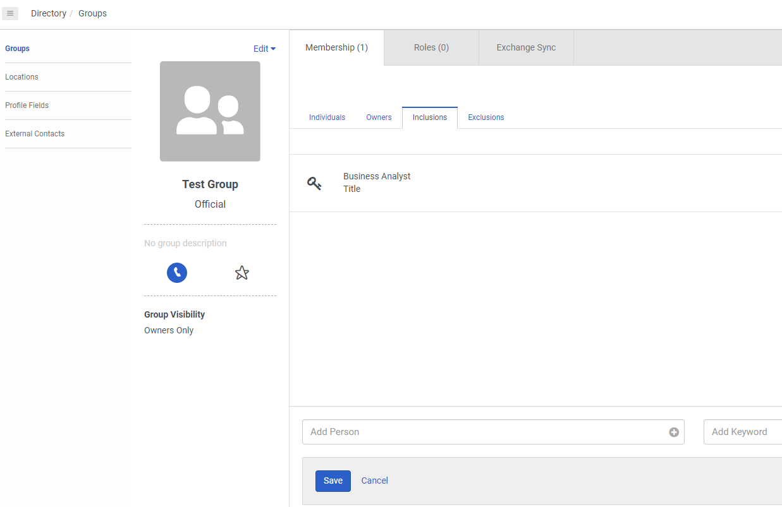

The system will dynamically add anyone with the key word match into the group 9and take them out if the key word is removed from their People Details (see note below). The group automatically appears in their chat under Official Groups. They don’t have to be invited and accept.

Notes: The Job title is stored on the People <Person Details> tab. It’s free format text so you have to make sure that everyone’s job titles have been loaded consistently in order for the rule to be workable. e.g my Job title is Business Analyst. The field to the right (Management) is Department.
