**Scheduled Reports Not Completing**

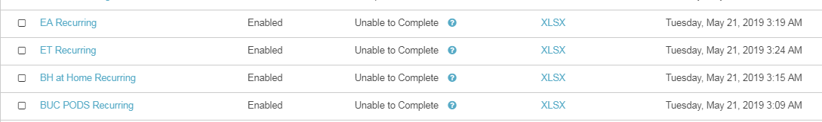

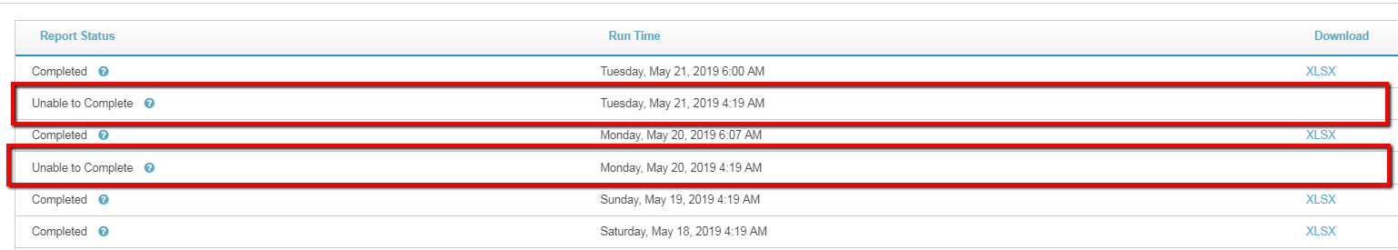

When one of our analysts clicks on his reports tab, he often sees this.

