**Using Documents in PureCloud**

**Workspaces**

In order to create a folder in the Documents space for teams to use, a work space needs to be added. Workspaces define who has access to the folders so other users can see them. If workspace security is not set up correctly, other people will not be able to see it.

1. Click on Admin button
2. Click on Workspaces under Documents

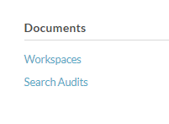

1. All workspaces you have access to will show up in this list.

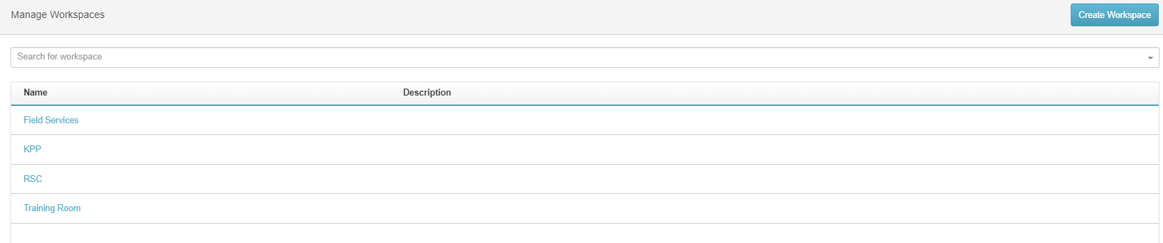

1. Click on ‘Create Workspace’ to add a new WorkSpace or folder to your documents.
2. Name the Workspace & add a description

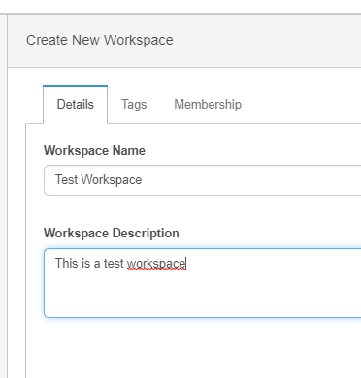

**NOTE: The tags do not need to be filled in at this time. They will automatically populate in this tab when they are applied in the documents.**

1. Click on the membership tab.

* Here is where the specific ‘Lead’ users need to be added. Search for them by name at the bottom of the screen.

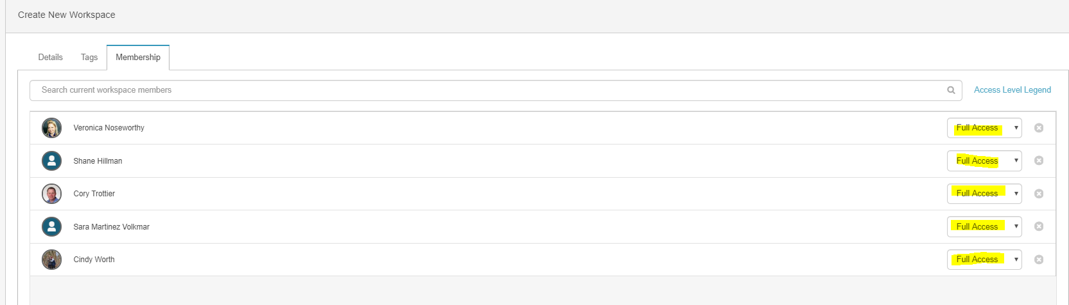

* When users are added, they are automatically given FULL ACCESS to the workspace. This access is Ok for supervisors & Team leads.

1. To add everyone else to the workspace, please add their group. This will allow the people within the groups to change, but allow everyone who is in the group access.

* For RSC, the group is Retail Service Center Agents. Everyone should be a part of this group who is part of the RSC.
* Change the drop down to say ‘READ ONLY’



**NOTE: The groups will need to a lower security than the team leads or supervisors or they will be able to change security, users in this list or documents added.**

**Using Documents**

1. Click on the documents button on the top bar.
2. All workspaces that you have been granted security to will show in your Document Dashboard.

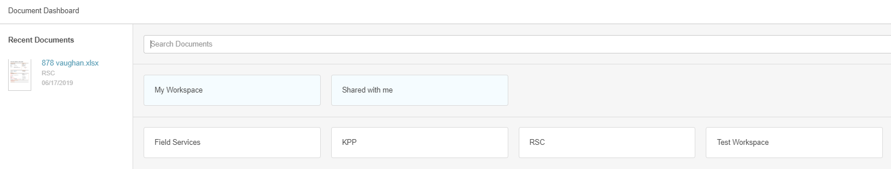

1. To open the workspace, hover the mouse overtop of the button & click open

**NOTE: If needing to upload multiple items to the folder, click on the + sign instead of open. This will allow you to bulk upload to the folder instead of doing it one at a time.**

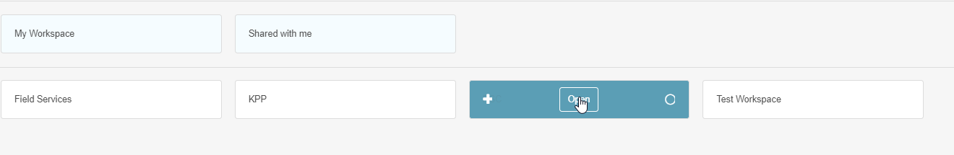

1. Each workspace can have multiple items added to it, once you open the workspace, you will see each item in list that can be sorted in multiple ways.

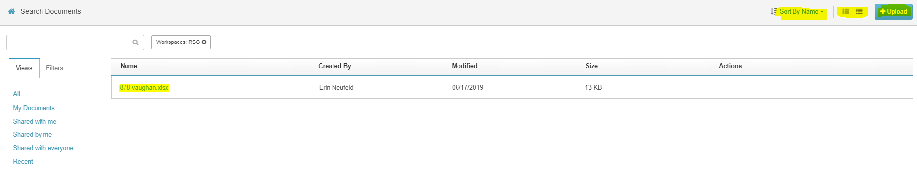

1. To upload documents into this folder as a one off basis, click on the top right hand Upload button.

* Search for the saved document & Upload.

1. To set up security for each document, Hover the mouse over the action side of the file, Click More > Properties

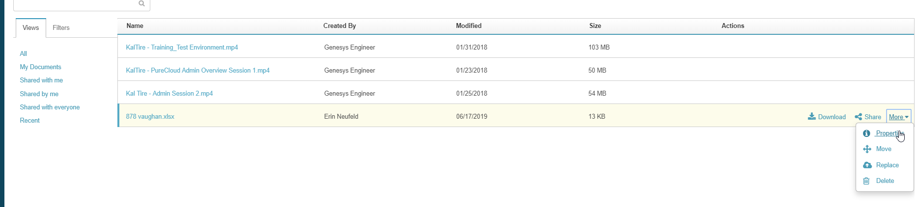

1. In the properties, you are able to add multiple tags for the document which can be searched for. In this example Below, I have tagged the store number & the city the store is located in.

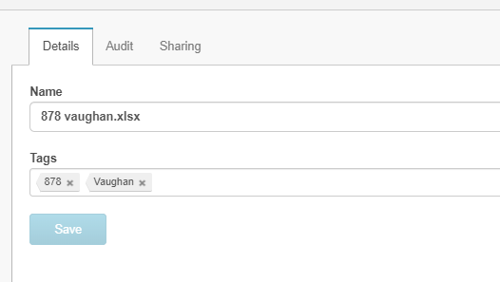

* The audit tab will show Date, Event, User & application information for each document.
* The sharing tab contains the link to the documents that can be shared to users within the system, the option for Public sharing, or Shared only by workspace security options.

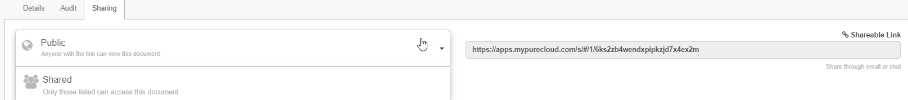

1. Public will allow anyone with document access, who also has access to the Workspace to access the documents.

**NOTE: Since all of our users have document access, but not all users will have workspace access, documents can be saved with a Public security type. They will not see the workspace if they do not have access.**

**Open a document in a new window**

The default for opening documents is to download it each time you wish to open it. If you wish to have it open in a new window and forgo the download, please use the below steps.

1. In the search documents section (documents > Click on Workspace folder required)
2. Click on any document to download it. It will show up in the bottom of the Chrome browser.
3. Right click on the document & select ‘Always open files of this type’

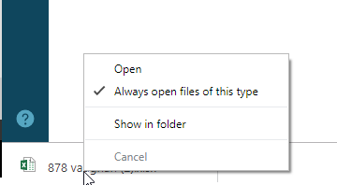

1. The next time you open a document within PureCloud, it will automatically open in a new window without being downloaded first.

NOTE: Each user may have to do this for the first time, so Chrome knows what to do with it.