IP Cards:

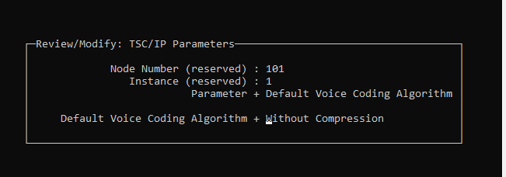

IP Phones:

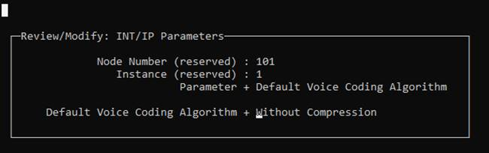

Sip trunk:

