Here We are welcome to the Customer and playing “Weclome to the Customer Centre”

And then we are initiating the BOT after that Customer say “Apple Care”

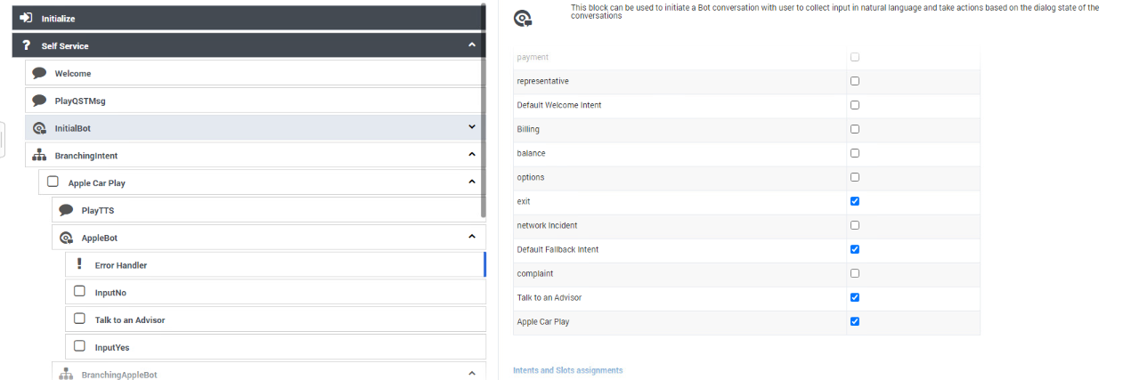

Then we are Branching

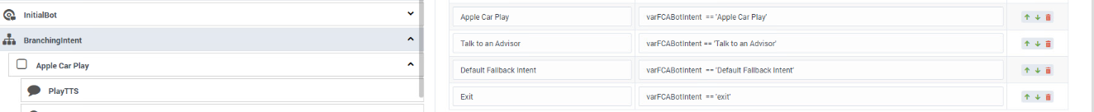

After Branching we are asking Customer
“Ok,You are calling about Using Apple Care Play, is that correct?”

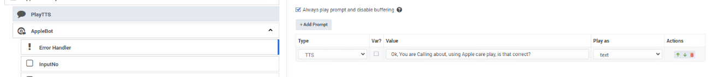

After Asking this Question

“Ok,You are calling about Using Apple Care Play, is that correct?”

Customer Has to Say “Yes” till here everything working

But MY Intent is never understood the “YES”

