Collect Mobile Number

Check to see if the first digit after the seventh ANI is a seven (UK Mobiles are 07***)

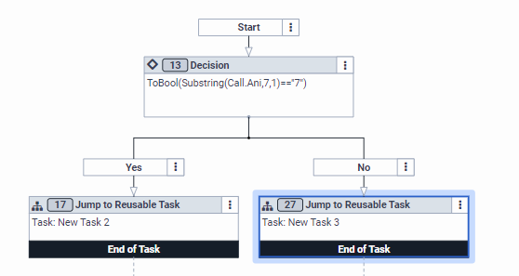

If yes update a variable with the thirteen digits from the right of the ANI (Gives full UK Mobile)

Then update a data table with the conversationId as the key and the mobile number and transfer to queue

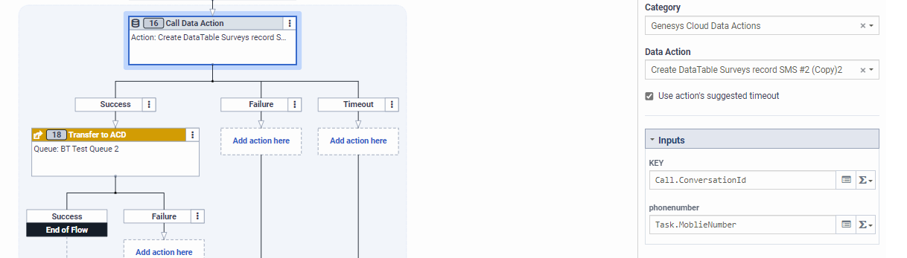
If no mobile is detected request the caller enter it
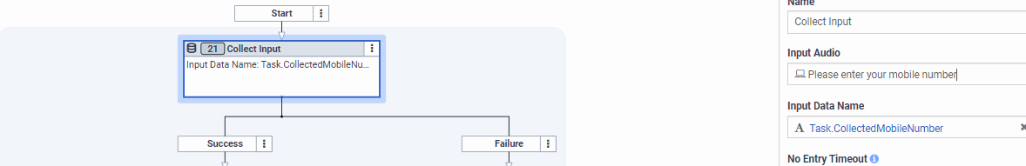

Now there are a number of checks within loops to ensure it’s a valid number, but I haven’t in this example.
Update the data table as above and transfer to queue

Send the Survey Via SMS

Within the survey flow do a data table look up to get the customer mobile number

Next send the agentless SMS

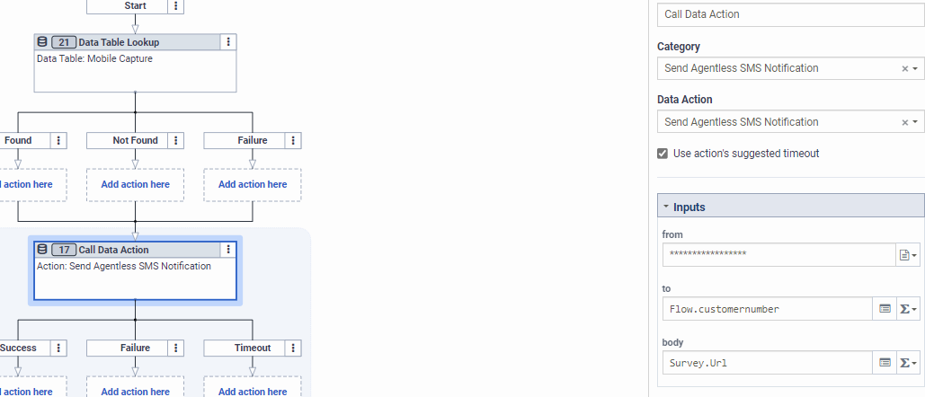

I would add another action after sending the sms to delete the row in the data table as well

