You have a couple options.
1. is modify the base handler: System_WrapUpRequest and in step 37 the timeout hard code it
2. use the customization point CustomWrapupRequest (reccomended over step 1) and basically copy all the base logic but hard code the timeout again.
(toR(GetAt(lsWGAttributeValues, Find(lsWGAttributeNames, c_sWGAttributeKeyPadWait, 0))) > 0.0) just set this as toR(121)
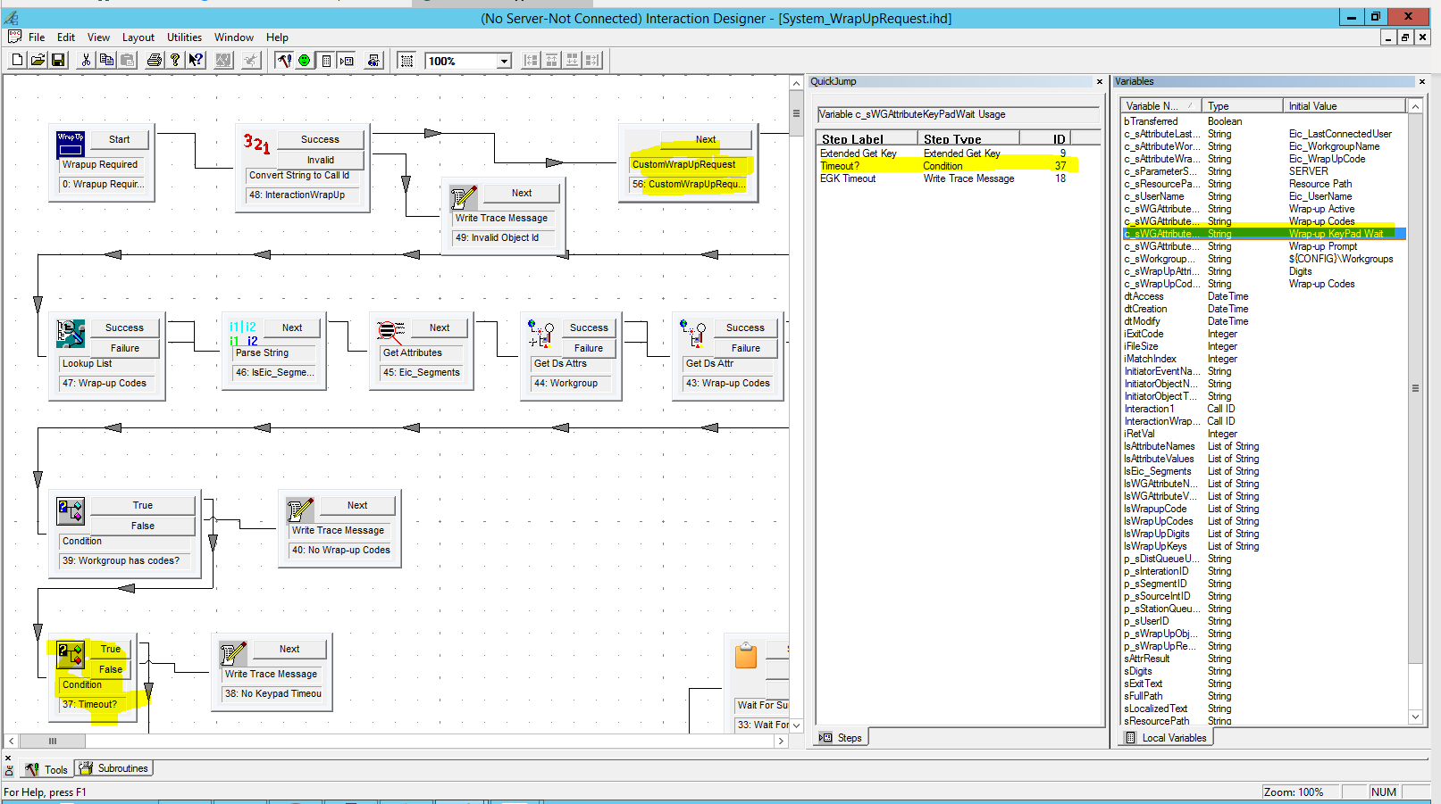
3. modify the option in DS the system will support a higher number but IA has a limit.
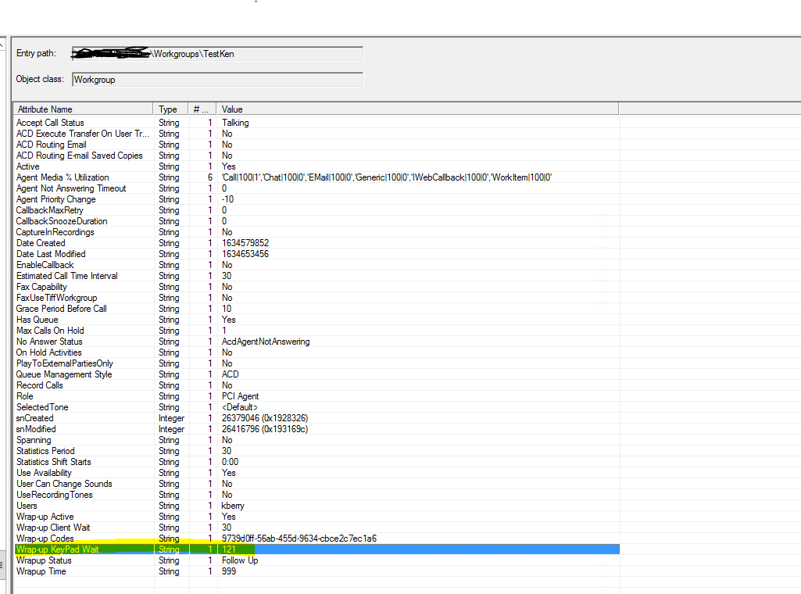
You will see IUA reflects this change but now you can't save any workgroups changes with this value as it will error like it did when trying to set it via IA.
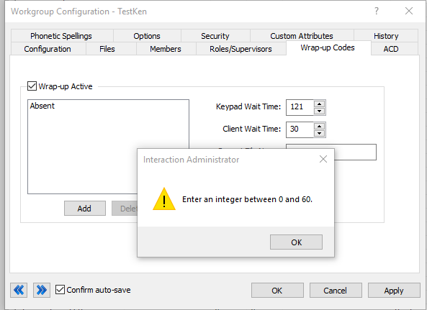
Now the most important part call deallocation is 120 seconds so anything longer than that will not be written to DB with out adjusting call de-allocation.
You can extend the deallocation time per interaction by setting the interaction attribute "Eic_DeallocationTime". This specifies the time (in seconds) for de-allocation to occur after disconnect. The default is 120 seconds. The maximum is 3600 seconds.
You may do this in attendant or in a handler like custom incoming call etc, I am unaware of any setting or server parameter to change this globally.

