Manual Assignment – Beta Instructions

How to test: (note: recommend testing with email)
- Ensure the appropriate permissions are assigned to the user updating the API
 | Assign to Others | Assign to Self | View* (existing)
Voice | conversation:call:assign | conversation:call:pull | conversation:call:view
Email | conversation:email:assign | conversation:email:pull | conversation:email:view
Chat | conversation:webchat:assign | conversation:webchat:pull | conversation:webchat:view
Messaging | conversation:message:assign | conversation:message:pull | conversation:message:view
Callback | conversation:callback:assign | conversation:callback:pull | conversation:callback:view

- Select queue to test with
  - Enable queue-level setting via API
    - GET/api/v2/routing/queues/<queueID>
      - Copy payload
    - PUT/api/v2/routing/queues/<queueID> (use payload from the previous GET step)
      - Insert a new row: ‘"enableManualAssignment": true,’ (recommend inserting into its own row after ‘skillEvaluationMethod’
        - See sample payload below
- Check queue settings to ensure evaluation method for you intend to test with is either ‘All Skills Matching’ or ‘Best Available Skills’
- Log in an agent to the test queue
  - Make sure agent have has no skills or proficiency
  - Note AgentID for later
- Send an email into the queue with and skill attached (skills are set in architect flow)
- If setup correctly, the email should be sitting in queue in a ‘waiting’ state
- To assign the interaction to the agent:
  - Find conversation ID of waiting interaction
  - Use new API: POST /api/v2/conversations/{conversationId}/assign
    - Insert conversationID into API payload where requested
    - Insert AgentID into body of payload
    - Send the request
    - If successful – you should receive a ‘202 Accepted’ response from the API and the agent should receive the alert notification to accept or decline the interaction.

Phase 1 Limitations
- Manual assignment will only work to agents in the same queue
- Utilization will be honored – so once an agent’s utilization is full for a specific media, they will not be eligible to receive an assigned interaction.
  - It’s very unlikely that when they do come available a supervisor would have enough time to manually assign an interaction as assignment would have already picked it up.
- Manual assignment will ignore all skills, languages, priority, time-in-queue, bullseye ring number, or Preferred Agent Routing score
- Agents must be on-queue and in an Idle, interacting, or communicating state
  - ‘Not_responding’ agents will not be eligible
- Agents cannot be assigned an interaction if they are already in an alerting state for another interaction.
- Agents must have the appropriate permissions to receive assigned media type.
- Interactions that are declined or not answered by an agent (timeout threshold reached) will return to queue where they may be assigned again until successfully answered.
NOTE: If you update the queue settings after enabling manual assignment – you will need to re-enable the queue via the API before testing again.

API Sample: Conversation > Assign > PUT
{
"id": "efcaa1f9-da08-4ed4-a297-99ebca52ede4",
"name": "ChrisBohlin",
"division": {
"id": "b825f73b-b96f-43fe-b9bc-f43c48d9d49b",
"name": "Home",
"selfUri": "/api/v2/authorization/divisions/b825f73b-b96f-43fe-b9bc-f43c48d9d49b"
},
"dateModified": "2020-07-14T19:02:58.741Z",
"modifiedBy": "0cbe4603-7a7d-4b7d-8fc9-e9799d309cf1",
"memberCount": 3,
"mediaSettings": {
"call": {
"alertingTimeoutSeconds": 8,
"serviceLevel": {
"percentage": 0.8,
"durationMs": 20000
}
},
"socialExpression": {
"alertingTimeoutSeconds": 300,
"serviceLevel": {
"percentage": 0.8,
"durationMs": 20000
}
},
"chat": {
"alertingTimeoutSeconds": 30,
"serviceLevel": {
"percentage": 0.8,
"durationMs": 20000
}
},
"callback": {
"alertingTimeoutSeconds": 30,
"serviceLevel": {
"percentage": 0.8,
"durationMs": 20000
}
},
"message": {
"alertingTimeoutSeconds": 30,
"serviceLevel": {
"percentage": 0.8,
"durationMs": 20000
}
},
"videoComm": {
"alertingTimeoutSeconds": 8,
"serviceLevel": {
"percentage": 0.8,
"durationMs": 20000
}
},
"email": {
"alertingTimeoutSeconds": 300,
"serviceLevel": {
"percentage": 0.8,
"durationMs": 86400000
}
}
},
"routingRules": [],
"acwSettings": {
"wrapupPrompt": "MANDATORY_TIMEOUT",
"timeoutMs": 120000
},
"skillEvaluationMethod": "ALL",
"enableManualAssignment": true,
"autoAnswerOnly": true,
"callingPartyName": "",
"callingPartyNumber": "",
"defaultScripts": {},
"selfUri": "/api/v2/routing/queues/efcaa1f9-da08-4ed4-a297-99ebca52ede4"
}
API Failure Errors:
- Queue not enabled for manual assignment
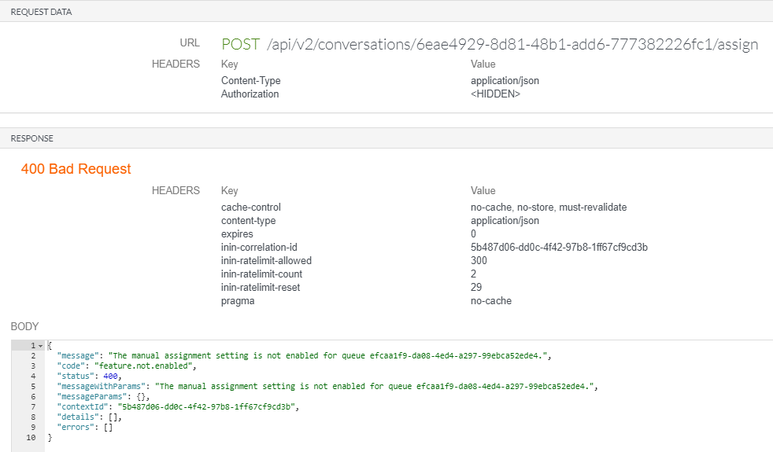

- Missing ‘conversation>call>assign’ permission:
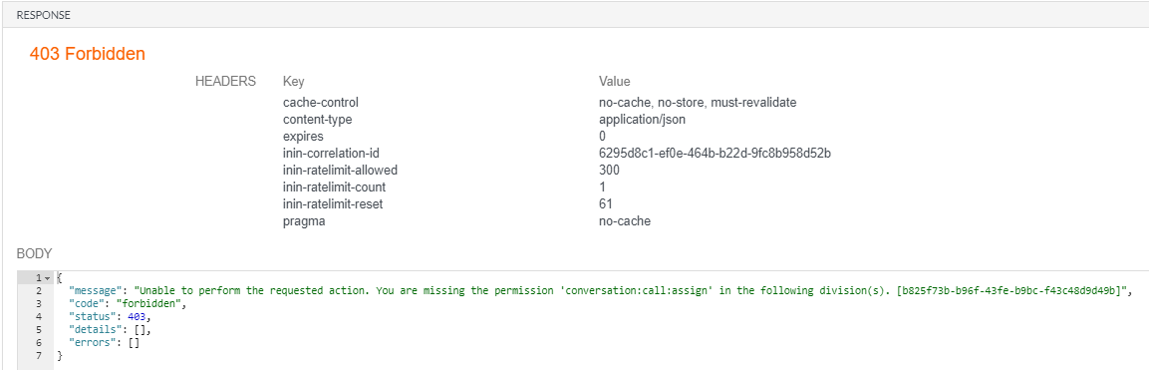

- Missing ‘conversation>call>pull’ permission
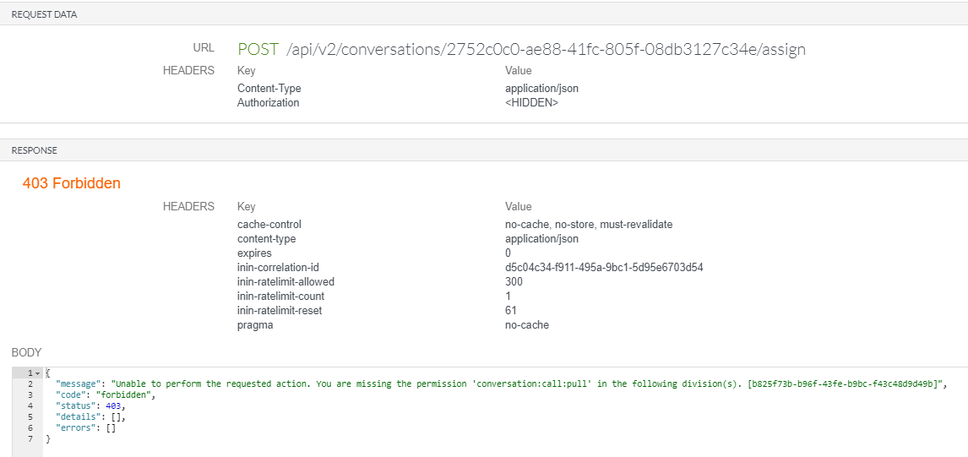

- Missing ‘conversation>email>pull’ permission
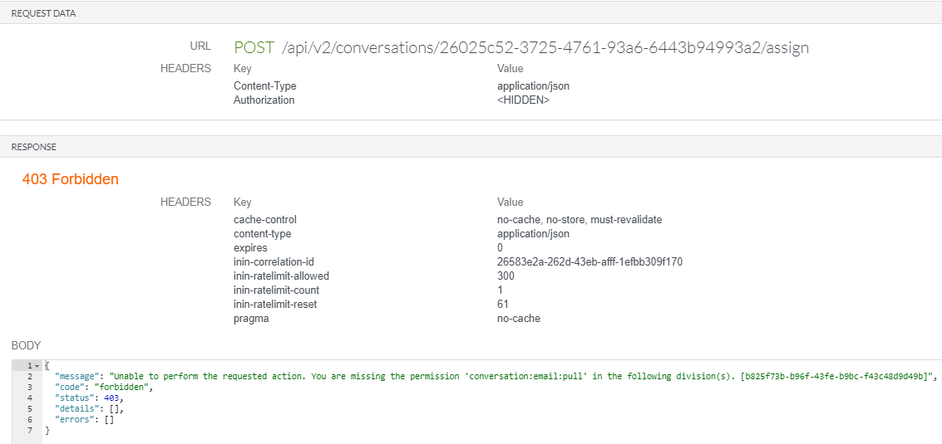

- User already alerting
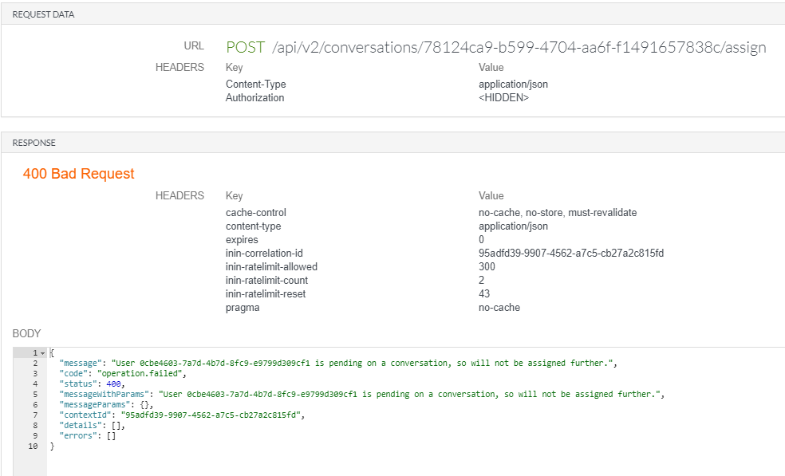

- Agent off-queue
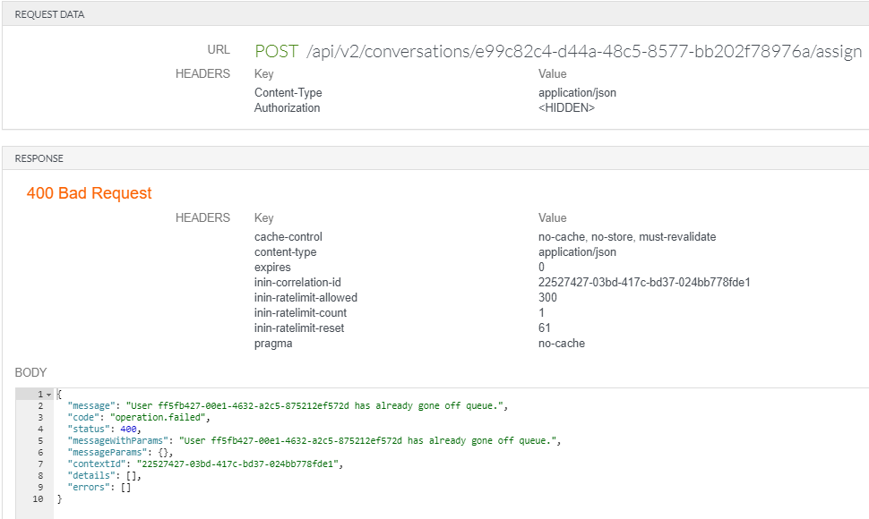

- Agent ‘not-responding’
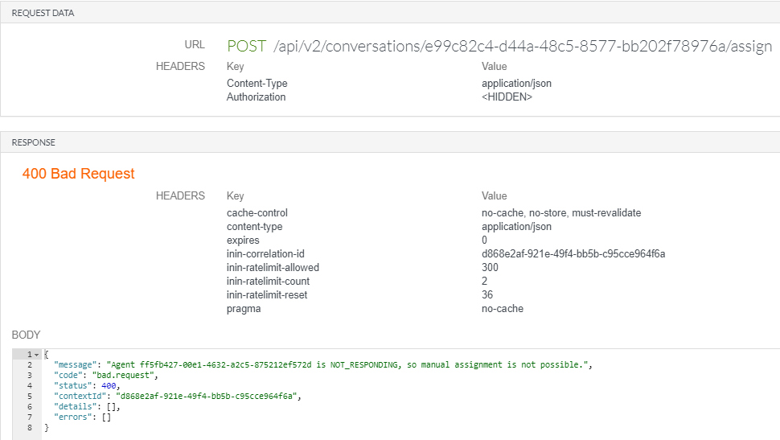

- Bad conversationID:
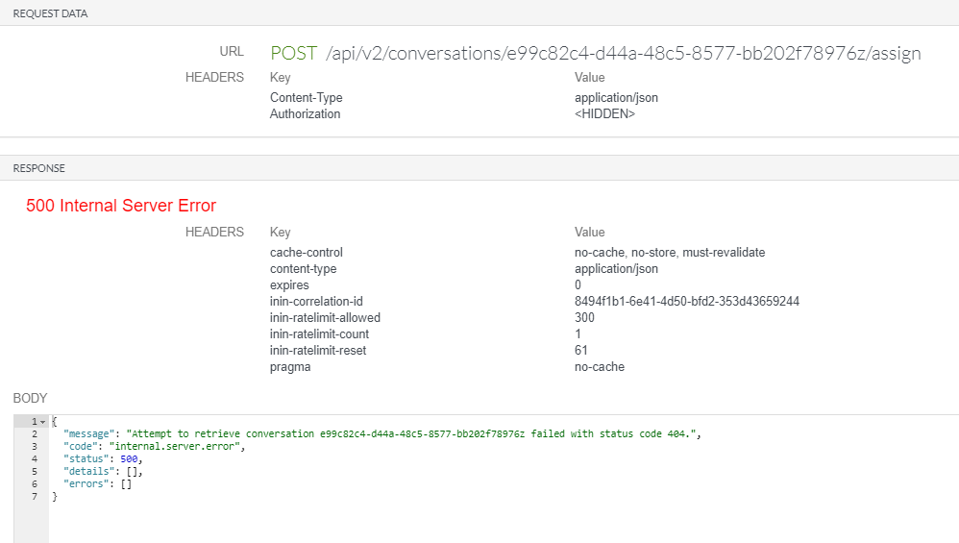

- Agent fully utilized
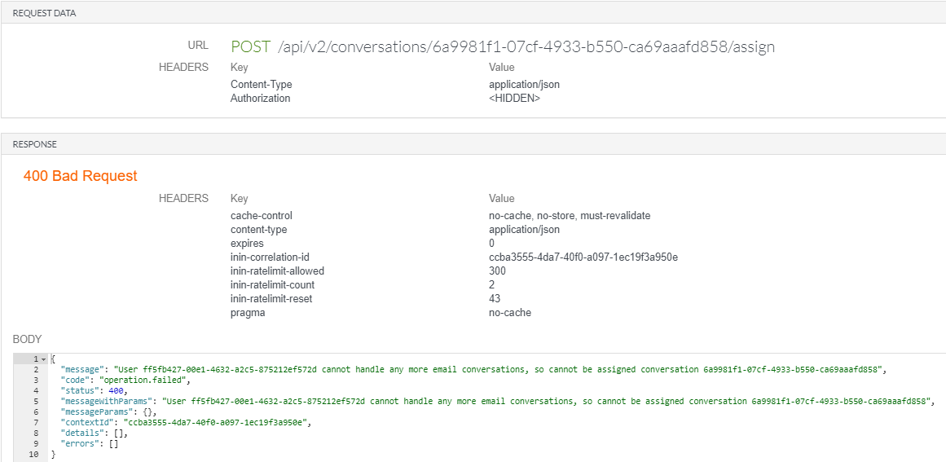

- Agent not active on queue
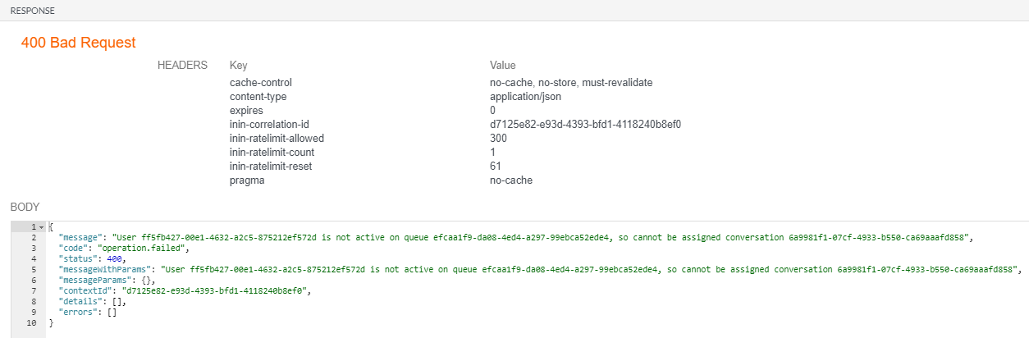

- Feature toggle not enabled on org:
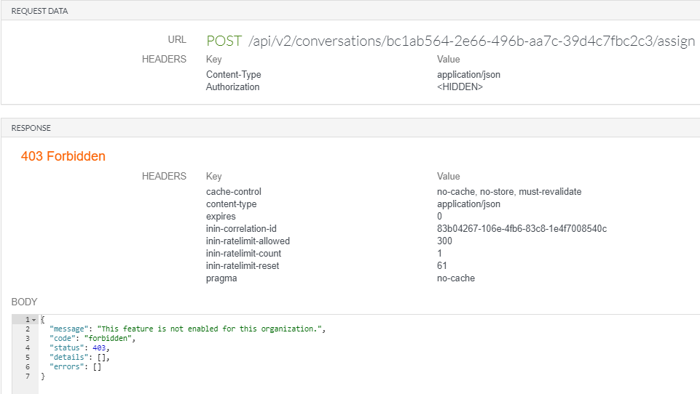

- User does not have permissions to accept
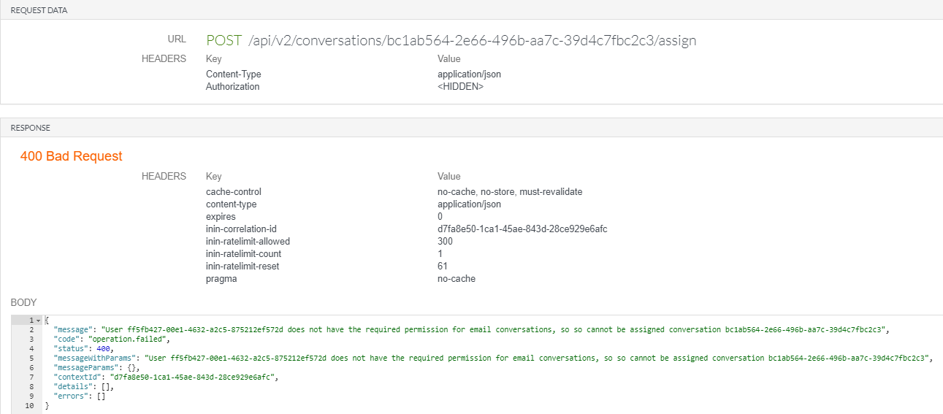

- Interaction already alerting another agent
