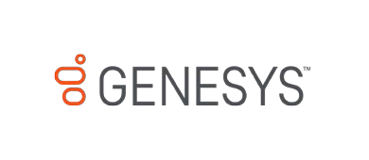

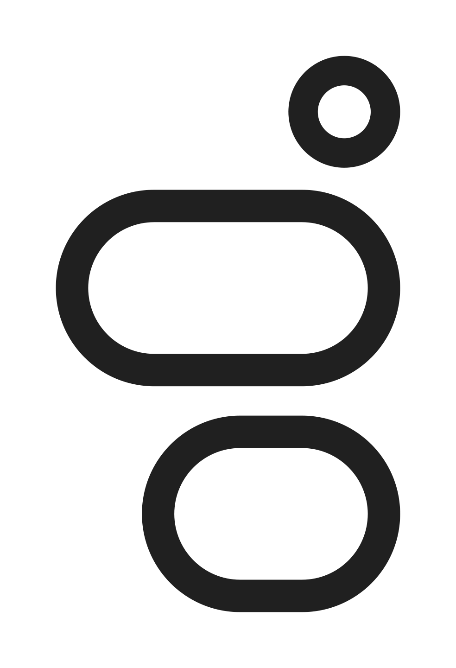
Genesys Cloud for WhatsApp Messaging
Customer Application

Getting Started with Genesys Cloud for WhatsApp Messaging

Please read, complete, and return the Customer Application on the next page to:
GenesysCloudWhatsAppRequests@genesys.com.

Customers must be approved by Facebook (who owns WhatsApp) to use the WhatsApp Business API platform. Approval is subject to guidelines in the Commerce Policy for WhatsApp and WhatsApp Business Policy. Please ensure your business use-case is aligned with these policies. Genesys will own and manage the WhatsApp Business Account (WABA) for customers. Customers must provide a valid Facebook Business Manager ID to begin the process, and the Business Manager must be Verified before it is reviewed for WhatsApp approval.

The most important immediate information is:

- Facebook Business Manager ID
See link here and image below for help finding this ID.
See page here to create a Business Manager if you do not have an existing BM.
- Business Name
This will be the name of your WABA (WhatsApp Business Account). The name should be the same (or similar) to your Business Manager name. This will expedite the review and approval process.

Please note, the Business Manager must be owned by the Brand that will interact with WhatsApp end-users. For example, a Business Manager owned by a Partner, Integrator, or Ad Agency cannot be accepted for customers.

After Genesys creates your WABA, you will need to complete Facebook Business Verification for your Business Manager: https://www.facebook.com/business/help/2058515294227817

Many customers have completed this Verification already. If your Facebook Business Manager is not Verified, please start this process as soon as possible to expedite onboarding. You can check your Verification status by visiting https://business.facebook.com/settings/ and clicking “Business Info” in the left-hand menu.

After your Business Manager is verified, Facebook will review your business for approval to use the WhatsApp Business API. Once your WABA is approved, we will reach out with details about next steps to activate your numbers in your Genesys Cloud org.

Please see the Genesys Cloud Resource Center for additional information and for WhatsApp pricing details:
https://help.mypurecloud.com/articles/configure-acd-messaging-for-whatsapp/
https://help.mypurecloud.com/articles/acd-messaging-pricing/

Customer Application
Company Legal Name
Company Legal Address (including Country)
Company URL
Genesys Cloud Org ID

Genesys Cloud Region
Customer Facebook Business Manager ID (see here)
Customer Facebook Business Manager Name
- If you don’t have a Facebook Business Manager Account, see instructions for creating one at this link.
- For customers, the Business Manager must be owned by the Brand that will interact with WhatsApp end-users.
A Business Manager owned by a Partner, Integrator, or Ad Agency cannot be accepted for customers.
Approval Criteria
Please note, some industries and businesses are not permitted use the WhatsApp Business API at this time.
Customer use-cases for the WhatsApp Business API must comply with Facebook’s Commerce Policy for WhatsApp. Customers agree to comply with the WhatsApp Business Policy when using WhatsApp.
Business Verification
Customers must complete Facebook Business Verification to use the WhatsApp platform:
https://www.facebook.com/business/help/2058515294227817
WhatsApp Phone Number(s) information:
WhatsApp Phone Number(s) (See requirements below)
The Display Name to be used with each phone number. This is the name end customers see in your public WhatsApp profile. It is subject to approval according to rules at this link.
Is this number(s) already activated with WhatsApp? If yes, is it (A) with another Business Service Provider using the WhatsApp Business API, or (B) active on an Android or iOS App?
WhatsApp Profile and Business Profile information (Optional, recommended):
Photo | Company photo displayed in WhatsApp to end customers | 640x640, PNG recommended
About | Short About status, displayed above phone number in WhatsApp profile | Max 139 chars
Address | Business Address | Max 256 chars
Description | Description of business, services, mission, etc. | Max 256 chars
Email | Public email displayed to end customers | Max 128 chars
Vertical | Choose from list at this link | Enumerated
Websites | Up to 2 public website URLs | Max 256 chars

WhatsApp Phone Number Requirements and Activation
- The phone number can be any valid landline or mobile number owned by the customer.
  - The number must receive a phone call or SMS message to receive a verification code.
  - If the phone number routes to an IVR, you must temporarily re-route it directly to a person so the activation code can be received.
- We will send instructions to add each approved number to your Genesys Cloud Org. Once created, you must activate it within 7 days. You can initiate the activation from the Genesys Cloud Admin UI and receive the activation code via voice call or SMS. The activation must be completed within 10 minutes after receiving the code. If the integration has expired after 7 days, please contact us at GenesysCloudWhatsAppRequests@genesys.com.
- Once activated, the number can be re-routed back to your IVR (if applicable) or disconnected from voice / SMS service. If you choose to disconnect it, you must retain ownership of the number.
- When activated, the WhatsApp integration must be routed to an Inbound Messaging Flow:
https://help.mypurecloud.com/articles/about-message-routing/
https://help.mypurecloud.com/articles/inbound-message-flows/

WhatsApp Pricing for Genesys Cloud
Please see the Genesys Cloud Resource Center for WhatsApp pricing details:
https://help.mypurecloud.com/articles/acd-messaging-pricing/

Sample Facebook Business Manager ID location:

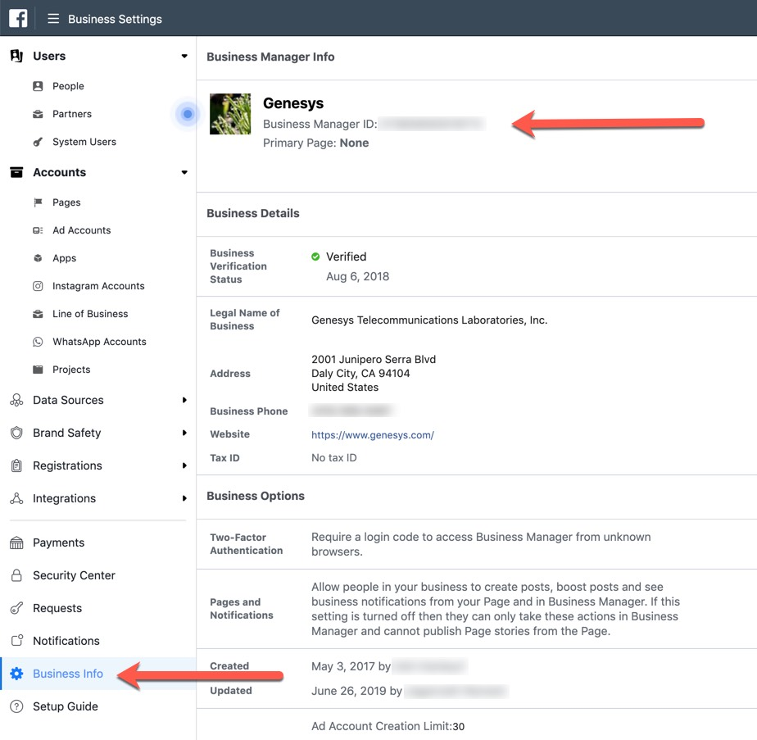

Frequently Asked Questions (FAQs)
What are Acceptable Uses for WhatsApp for Genesys Cloud?
Please refer to WhatsApp’s Commerce Policy and Business Policy for acceptable use. WhatsApp may limit the number of customers you can message or suspend your access for repeated violations of their policies. WhatsApp may also decline to approve customers whose primary business functions do not align with these policies. In addition, special consideration is given to applicants from governmental entities; WhatsApp evaluates these on a case-by-case basis.

My number is already in use with WhatsApp. Can I migrate it to Genesys Cloud?
If the number is in use with the WhatsApp Messenger or WhatsApp Business App on iOS or Android, it can be migrated to Genesys Cloud, but first you will need to delete the current account. If the number is already active with another Business Service Provider on the WhatsApp Business API, Genesys Cloud can support migration via a manual process. Please work with GenesysCloudWhatsAppRequests@genesys.com to determine your next steps. Note that a period of downtime is required in order to complete the migration.

What kinds of phone numbers are supported on the WhatsApp Business API?
International landline and mobile numbers with a country code may be used with the WhatsApp Business API. The number must have active Voice or SMS service to receive an activation code after you add it to Genesys Cloud. WhatsApp is a purely digital, internet-based channel. After activation, all communication is done via the internet. Your activated WhatsApp number is more like an “account ID”, like an email address or username. Telephony and mobile service for your number is separate from WhatsApp’s service. After activation with WhatsApp, you may even choose to disconnect the number if you do not wish to receive phone calls or text messages. You should retain ownership of the number, however, so another party cannot acquire it.

Are toll-free numbers supported on the WhatsApp Business API?
Toll-free numbers are allowed so long as your country code is included. The reason is that toll-free numbers without country codes cannot be uniquely identified — the same number can apply for two different countries. Also note that there are added complexities around toll-free numbers. Typically, if you call a toll-free number with the country code when you're inside the country, it will fail. This means that there is a chance your customers from your country will try to dial what shows in the business contact (country code included) and they won't be able to reach you. If this is a concern, you will need to let them know explicitly. Of special note, 0800 or 00800 toll-free numbers are not supported.

Why does my business need its own Facebook Business Manager (BM) to use WhatsApp?
Facebook reviews each business that applies to use the WhatsApp Business API with a Business Service Provider like Genesys. The WhatsApp team may review your Facebook page or website and may ask clarifying questions about your use-cases. Your WhatsApp Business Account (WABA) will have a 1:1 connection with your BM, and your business is the responsible party for complying with WhatsApp policies. Further, WhatsApp prohibits partners, vendors, aggregators, or managed service parties from owning or “sub-letting” WhatsApp Numbers in their WABAs for other businesses. The Display Name of your number must be closely related to your BM and WABA name or be associated with a Brand, Product, or Trade Name owned by your business (documentation of this may be required).
If a service provider or ad agency operates your primary Facebook page, ad campaigns, or other business under their BM, you may still create one for use with WhatsApp under your business name. BMs are free to create. Please see Facebook’s page on Creating a Business Manager for details.

My phone number routes to our Main IVR. Do I need to re-route this to receive a WhatsApp activation call?
When you add the WhatsApp integration to your Org and request a confirmation code, WhatsApp will call (or text) your number with the code. A live person must be available to answer the call and receive the code. WhatsApp’s automated service that makes these calls will not navigate IVR / DTMF menus. When the call is answered, the bot will announce the code five (5) times and then disconnect. How you handle this depends on your IVR and business needs:
- If your IVR or Genesys Cloud flow routes directly to a Queue, and your Agents are available to answer the call immediately, you may not need to re-route the number. This works best if your IVR has no introductory message (or it is very short). It also works best if the call routes to a Queue with a small number of Agents. If you use this method, be sure there is no wait time in the Queue.
- If you can re-direct your number from an IVR to a direct number (example: cell phone) temporarily during inactive hours, this is the easiest method. This usually takes 1 – 2 minutes at most.
- If your IVR is high-volume and cannot be re-routed for business reasons, we can request a list of ANIs (originating numbers) from WhatsApp Support. The activation call will come from one of these numbers. You may configure an exception in your IVR flow to recognize these ANIs and redirect them to a direct number, such as your cell phone, while routing other calls normally.

Can I have a WhatsApp Business Account as a partner, vendor, managed service provider, BPO, or similar business?
Yes. Partners and similar businesses may have a WhatsApp Business Account (WABA) and activate numbers that are directly associated with and owned by your business. Valid use-cases include testing, demonstrations, and supporting your direct customers (that is, other businesses that purchase your services). You may not own WhatsApp numbers that service your customer’s customers – the end-users contacting those Brands. Partners may offer consulting services related to configuration, integrations, and general operation of the channel. Service providers and BPOs may operate the channel for a customer, but the customer must still own the WhatsApp number and is the responsible party for compliance with WhatsApp’s policies. This is a reason each end-Brand must have its own verified Business Manager.

What is the 24 hour “Customer Service” window?
To reduce “spam” or “junk” messages to end-users, WhatsApp implements a 24-hour “Customer Service” window. If a user contacts your business, you can respond with any type of message in the next 24 hours. This type of message is free. Each time the end-user sends another inbound message, the 24-hour period resets. After 24 hours have passed since the last inbound message, only a template message may be sent. This is a paid notification. Genesys Cloud will disable the Agent’s text input after 24 hours elapse from the last inbound message, indicating that only template messages are available. This may occur, for example, if your contact center is closed for a weekend or holiday and more than 24 hours elapse before your Agents have a chance to answer.

What are Message Templates?
Message Templates are pre-configured messages in your WhatsApp Business Account. WhatsApp reviews and approves these templates, and they must fit into certain categories such as Account Update, Appointment Update, Issue Resolution, or Shipping Update. Advertising, marketing, or promotional messages are not permitted, such as coupons or upselling. Generally, these templates must be customer-centric and high value, designed to give users information they have asked to receive. A common Message Template used with Genesys Cloud is “Issue Resolution”, similar to: “We’re sorry we couldn’t get to your message right away. If you still need assistance, please reply with Yes.” Such a template encourages the user to respond, so another 24-hour Customer Service window opens and Agents can converse freely with the user. Message Templates may have placeholder fields to be filled dynamically, usually with a customer’s name, account number, support case id, etc. Please refer to WhatsApp’s guidelines on Template Messages.

How do I request a Message Template for my WhatsApp Business Account?
Please refer to the Resource Center for instructions and a downloadable form to request Message Templates. When approved, we will email you instructions on configuring the Template in Genesys Cloud.

What are HSMs (Highly Structured Messages)?
See “Message Templates”, above. WhatsApp refers to “HSMs” as “Template Messages”.

Can I use automation or bots with the WhatsApp Business API?
You may use automation when responding during the Customer Service Window, but must also have available prompt, clear, and direct escalation paths to human agents. See the WhatsApp Business Policy for details. Valid escalation paths include human Agent handoff in-thread, phone number, email, web support form, or prompting an in-store visit.

Can I change my Phone Number’s Display Name?
Yes. The display name change must be reviewed and approved by WhatsApp. When approved, a new integration certificate will be generated. You must delete your current WhatsApp integration and create a new one with the new certificate to complete the name change. We recommend doing this during off-peak hours and test-dialing or texting the number first to ensure you can receive the new activation code.

How can I update my Logo or other public Profile information?
Email us at GenesysCloudWhatsAppRequests@genesys.com for requests to change profile information. See the application above for the available fields.

What are a “Message Links” (aka, “short link”) and QR Codes?
Once your number is active, you may request a Message Link and QR Code. These let end-users easily add your number to WhatsApp on their device without manually entering your number. Message Links can be included in mobile apps, email signatures, and websites, for example. QR Codes might be included on websites or printed and affixed to physical locations, advertisements, or products. Short links and QR Codes optionally have pre-populated messages that are filled when users tap, click, or scan it. See details and the QR Code request form in our Resource Center.

What is a WhatsApp “Official Business Account?”
A business account on WhatsApp can either be listed as an "Official business account" (OBA) or a regular "Business account". An OBA will have a green badge for the business’s profile. At this time, only certain business accounts are listed as an OBA. This is solely at Facebook’s discretion. Listing a business as an "Official business account" is based on a variety of factors, such as whether the brand is notable. Generally, Facebook reserves Official Business accounts for internationally recognized brands. Being Verified on Facebook does not help your business to become an Official Business Account. Please see How to Get and Official Business Account for details, and contact us at GenesysCloudWhatsAppRequests@genesys.com to request an OBA after your WhatsApp number is active.

Does the WhatsApp Business API support Group chat, Voice calls, or Video calls?
The API does not support these features currently.

Is WhatsApp encrypted? Does Facebook have access to the content of WhatsApp messages?
WhatsApp is an end-to-end encrypted channel. Facebook’s documentation indicates they do not have visibility into the text or media content of messages sent via the WhatsApp Business API.
Please see these links for information and statements about WhatsApp encryption:
- https://developers.facebook.com/docs/whatsapp/overview/
- https://developers.facebook.com/docs/whatsapp/faq/#faq_188619461766385
- https://www.facebook.com/notes/mark-zuckerberg/a-privacy-focused-vision-for-social-networking/10156700570096634/

Can I have multiple Business Managers or WhatsApp Business Accounts (WABAs)?
Facebook’s guidance is that a business should only have one Facebook Business Manager. If your business has significantly different entities, creating additional BMs is possible. Each BM must go through Business Verification separately for approval to use the WhatsApp Business API.
Having multiple WABAs for a BM is also possible, but it’s generally advised to have as few as possible. Multiple WABAs introduces additional management overhead. For example, Message Templates are not shared among WABAs, and if they are needed in each WABA, they would need reviewed and approved multiple times. In addition, phone numbers in a single WABA can be integrated into different Genesys Cloud orgs, so it is rare to need multiple WABAs.

Are any countries blocked from using the WhatsApp Business API?
Yes – currently, numbers in Crimea (+7978), Cuba (+53), Iran (+98), North Korea (+850), Syria (+963) are blocked from the WhatsApp Business API. In addition, businesses may not knowingly communicate with users in these countries regardless of the number’s country code.

