Once you click on the Agent’s name on the Alert

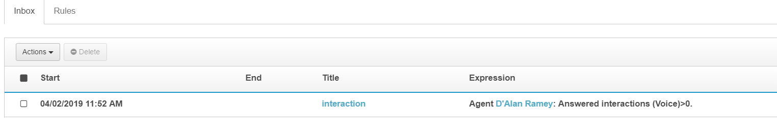
It Gives you directly the details of the agent

