Twitter Issue:
Created 2 Projects
Smartconnect1 and smartconnect123 and tried to config below keys and token to genesys.
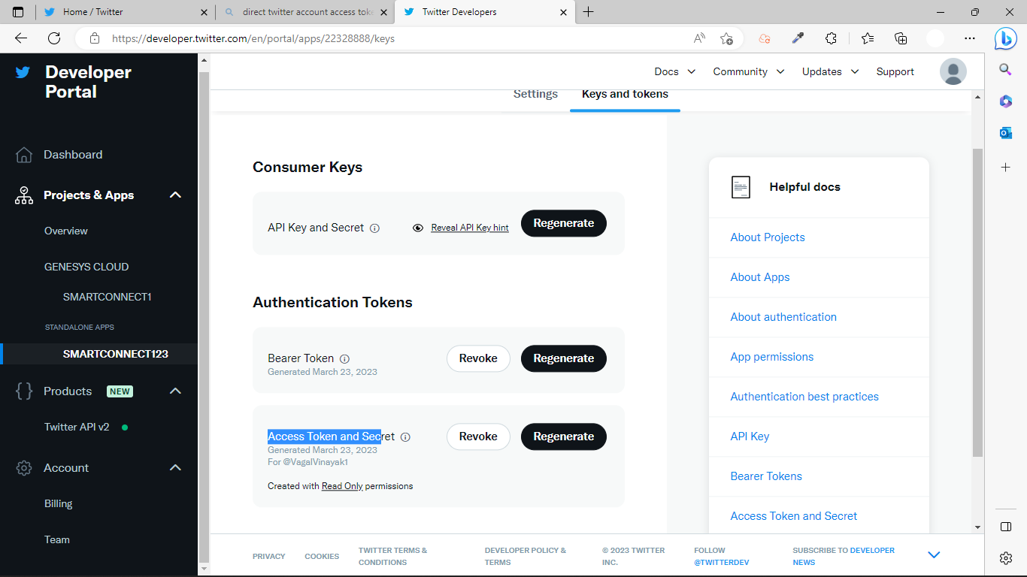

2> Genesys Cloud Configuration
Error: Integration creation failed for an unknown reason.

